**TARP LOCALHOST WEBSITE**

Software Needed: WAMP server

1. Install WAMP Server in your local Computer
2. Copy and paste the files in the Website zip folder into the installed location inside the “www” folder.
3. Open Phpmyadmin in WAMP server.

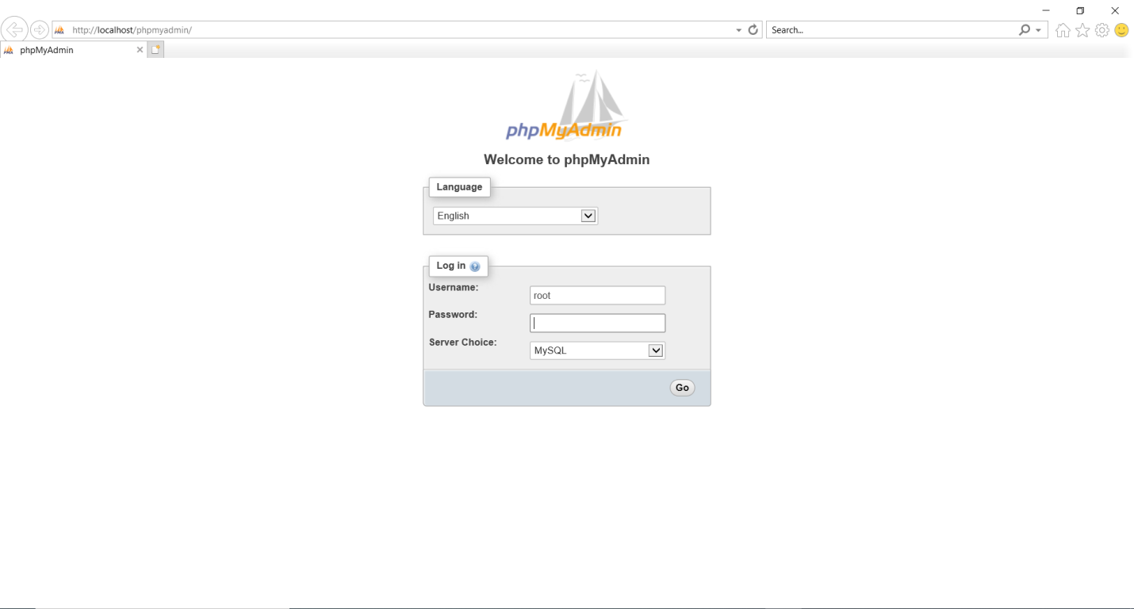

The user name is generally “root” with no password unless changed during installation.

1. Create a new database in any name and inside that database create a new table named “users”. You can use the sql query inside the “database.sql” file to create the table.

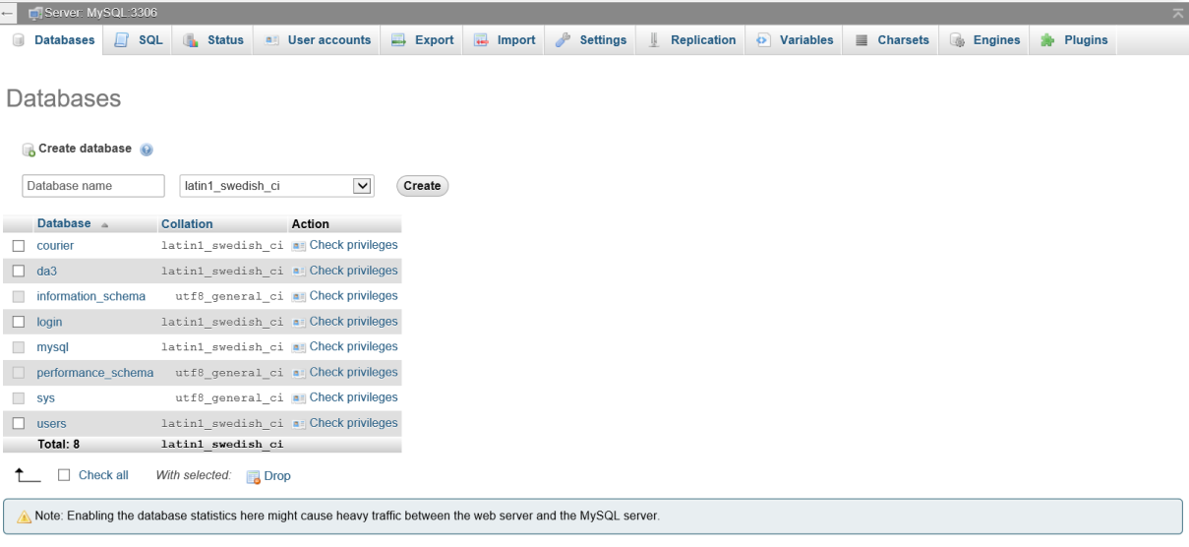

Once Database is created like above. Copy paste the contents inside the “database.sql” file to create the table.

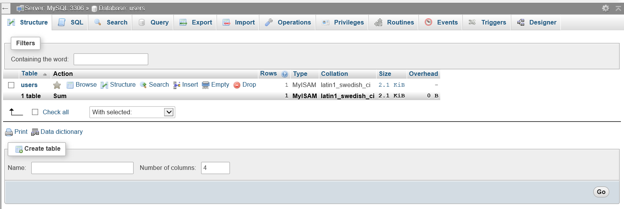

1. You can access the website using this url “http://localhost/login.php”